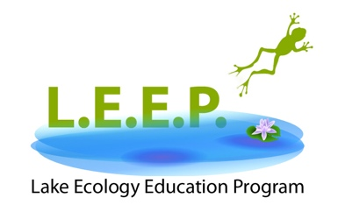

PHOTO RELEASE FORM

The Lake Ecology Education Program run by [Organization Name] has my permission to use my child’s photograph to share the outreach event publicly. I understand that the images may be used in print publications, online publications, presentations, and websites. I also understand that no royalty, fee or other compensation shall become payable to me or the program from such use.

Parent/Guardian’s Signature: _____________________________________ Date ______________
Parent/Guardian’s Name: ________________________________________
Child’s Name: __________________________________________________

